DFA Minimization using Myphill-Nerode Theorem

Algorithm

**Input** − DFA

**Output** − Minimized DFA

**Step 1** − Draw a table for all pairs of states (Qi, Qj) not necessarily connected directly [All are unmarked initially]

**Step 2** − Consider every state pair (Qi, Qj) in the DFA where Qi ∈ F and Qj ∉ F or vice versa and mark them. [Here F is the set of final states]

**Step 3** − Repeat this step until we cannot mark anymore states −

If there is an unmarked pair (Qi, Qj), mark it if the pair {δ (Qi, A), δ (Qi, A)} is marked for some input alphabet.

**Step 4** − Combine all the unmarked pair (Qi, Qj) and make them a single state in the reduced DFA.

Example

Let us use Algorithm 2 to minimize the DFA shown below.

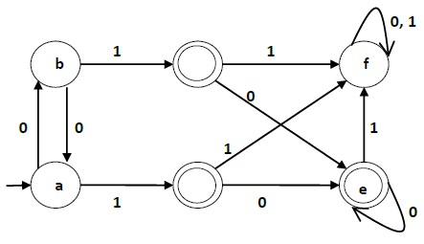

**Step 1** − We draw a table for all pair of states.

|  |  |  |  |  |  |  |
| --- | --- | --- | --- | --- | --- | --- |
|  | **a** | **b** | **c** | **d** | **e** | **f** |
| **a** |  |  |  |  |  |  |
| **b** |  |  |  |  |  |  |
| **c** |  |  |  |  |  |  |
| **d** |  |  |  |  |  |  |
| **e** |  |  |  |  |  |  |
| **f** |  |  |  |  |  |  |

**Step 2** − We mark the state pairs.

|  |  |  |  |  |  |  |
| --- | --- | --- | --- | --- | --- | --- |
|  | **a** | **b** | **c** | **d** | **e** | **f** |
| **a** |  |  |  |  |  |  |
| **b** |  |  |  |  |  |  |
| **c** | ✔ | ✔ |  |  |  |  |
| **d** | ✔ | ✔ |  |  |  |  |
| **e** | ✔ | ✔ |  |  |  |  |
| **f** |  |  | ✔ | ✔ | ✔ |  |

**Step 3** − We will try to mark the state pairs, with green colored check mark, transitively. If we input 1 to state ‘a’ and ‘f’, it will go to state ‘c’ and ‘f’ respectively. (c, f) is already marked, hence we will mark pair (a, f). Now, we input 1 to state ‘b’ and ‘f’; it will go to state ‘d’ and ‘f’ respectively. (d, f) is already marked, hence we will mark pair (b, f).

|  |  |  |  |  |  |  |
| --- | --- | --- | --- | --- | --- | --- |
|  | **a** | **b** | **c** | **d** | **e** | **f** |
| **a** |  |  |  |  |  |  |
| **b** |  |  |  |  |  |  |
| **c** | ✔ | ✔ |  |  |  |  |
| **d** | ✔ | ✔ |  |  |  |  |
| **e** | ✔ | ✔ |  |  |  |  |
| **f** | ✔ | ✔ | ✔ | ✔ | ✔ |  |

After step 3, we have got state combinations {a, b} {c, d} {c, e} {d, e} that are unmarked.

We can recombine {c, d} {c, e} {d, e} into {c, d, e}

Hence we got two combined states as − {a, b} and {c, d, e}

So the final minimized DFA will contain three states {f}, {a, b} and {c, d, e}

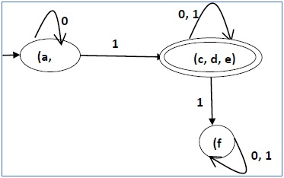

DFA Minimization using Equivalence Theorem

If X and Y are two states in a DFA, we can combine these two states into {X, Y} if they are not distinguishable. Two states are distinguishable, if there is at least one string S, such that one of δ (X, S) and δ (Y, S) is accepting and another is not accepting. Hence, a DFA is minimal if and only if all the states are distinguishable.

Algorithm 3

**Step 1** − All the states **Q** are divided in two partitions − **final states** and **non-final states** and are denoted by **P0**. All the states in a partition are 0th equivalent. Take a counter **k** and initialize it with 0.

**Step 2** − Increment k by 1. For each partition in Pk, divide the states in Pk into two partitions if they are k-distinguishable. Two states within this partition X and Y are k-distinguishable if there is an input **S** such that **δ(X, S)** and **δ(Y, S)** are (k-1)-distinguishable.

**Step 3** − If Pk ≠ Pk-1, repeat Step 2, otherwise go to Step 4.

**Step 4** − Combine kth equivalent sets and make them the new states of the reduced DFA.

Example

Let us consider the following DFA −

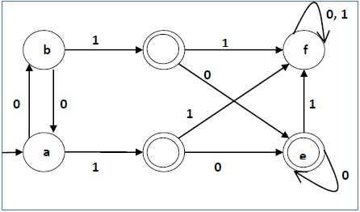

|  |  |  |
| --- | --- | --- |
| **q** | **δ(q,0)** | **δ(q,1)** |
| a | b | c |
| b | a | d |
| c | e | f |
| d | e | f |
| e | e | f |
| f | f | f |

Let us apply the above algorithm to the above DFA −

* P0 = {(c,d,e), (a,b,f)}
* P1 = {(c,d,e), (a,b),(f)}
* P2 = {(c,d,e), (a,b),(f)}

Hence, P1 = P2.

There are three states in the reduced DFA. The reduced DFA is as follows −

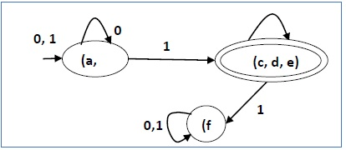

|  |  |  |
| --- | --- | --- |
| **Q** | **δ(q,0)** | **δ(q,1)** |
| (a, b) | (a, b) | (c,d,e) |
| (c,d,e) | (c,d,e) | (f) |
| (f) | (f) | (f) |